|  |  |
| --- | --- |
| Sony Alpha A7C  Máy ảnh Sony Alpha A7C (Black) + Lens 28-60mm F/4-5.6 | Chính hãng  Sony A7C black with 28-60mm 1 Sony A7C black with 28-60mm 5 Sony A7C black with 28-60mm 3 Sony A7C black 6 | **Featured information:**  Full-frame 24.2MP sensor  Continuous shooting at 10 frames/second  693-point focus system  Articulating screen  Price: $ 2000  Lens Mount  Sony E  Sensor Format  Full-Frame (1x Crop Factor)  Resolution  24.2 Megapixels  Size photo  6000 x 4000  Image Proportions  1:1, 3:2, 4:3, 16:9  Sensor Type  CMOS  Image Format  JPEG, Raw  Anti-Vibration  Sensor-Shift, 5-Axis |

**Overview:**

It can be seen that the Sony Alpha A7C is a Full-frame camera with extremely compact size, similar to the A6xxx series. Compared to other A7 series cameras, the A7C is about 20% smaller and lighter, measuring 124 x 71.1 x 59.7mm and weighing about 509g. The magnesium alloy chassis and weather-resistant design provide a durable structure that allows the A7C to be used in a variety of conditions.

The device still has a 0.39 inch XGA OLED electronic viewfinder with 2.36 million pixels for bright, clear, highly detailed images. The 3-inch flip-up touch screen like the A7S III offers high flexibility, which is very beneficial when working at difficult angles such as high or low angles.

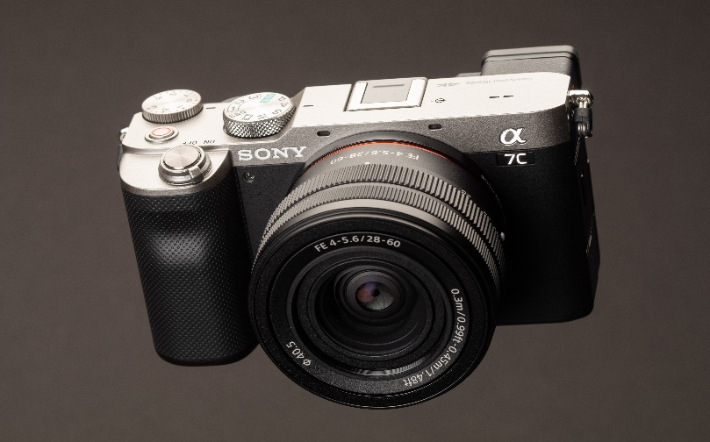

The sensor and processor combination also provides rapid burst shooting at up to 10 fps at full resolution for JPEG images, or 115 consecutive RAW images in AF mode. / Full-time AE operates with mechanical shutter or electronic shutter.

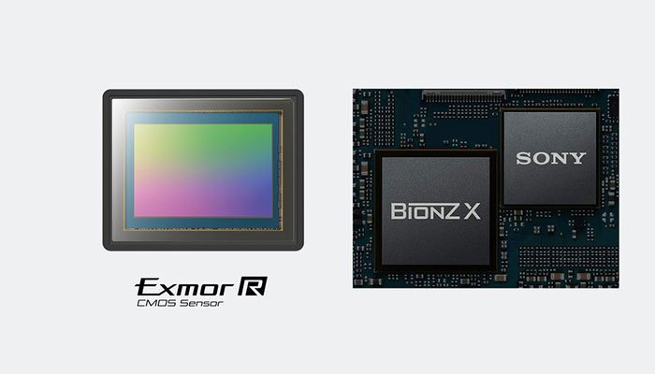

Sony A7C uses 5-axis SteadyShot Inside image stabilization technology, providing effective anti-shake up to 5 stops, maximum support for both filming and photography needs. This technology helps users more confidently take handheld photos even when shooting with low shutter speeds, or using with third-party lenses via a mount adapter.

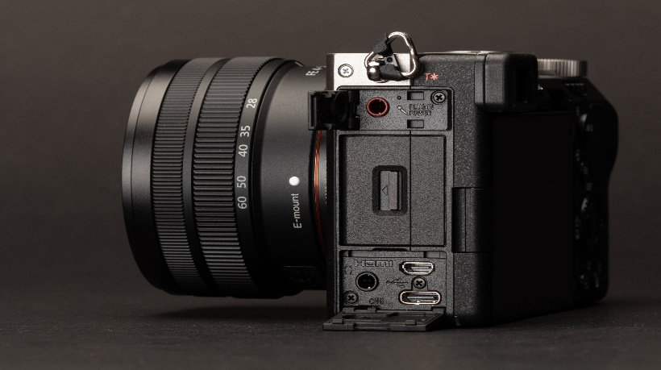

Wifi and Bluetooth modules enable easier connection between the camera and mobile devices. The device supports both 2.4 and 5.0 GHz bands, along with NFC one-touch connection. USB-C connection ports, 3.5mm audio jack including Mic-in and headphones are still equipped on the camera body. The Sony A7C supports a single UHS-II SD card slot for fast transfer speeds.